**INSTALLATION OF PYTHON 3.7.0 SHELL**

|  |  |
| --- | --- |
| **Date** | **7 November 2022** |
| **Team ID** | **PNT2022TMID50805** |
| **Project Name** | **Project – Hazardous Area Monitoring for Industrial Plants by IoT** |

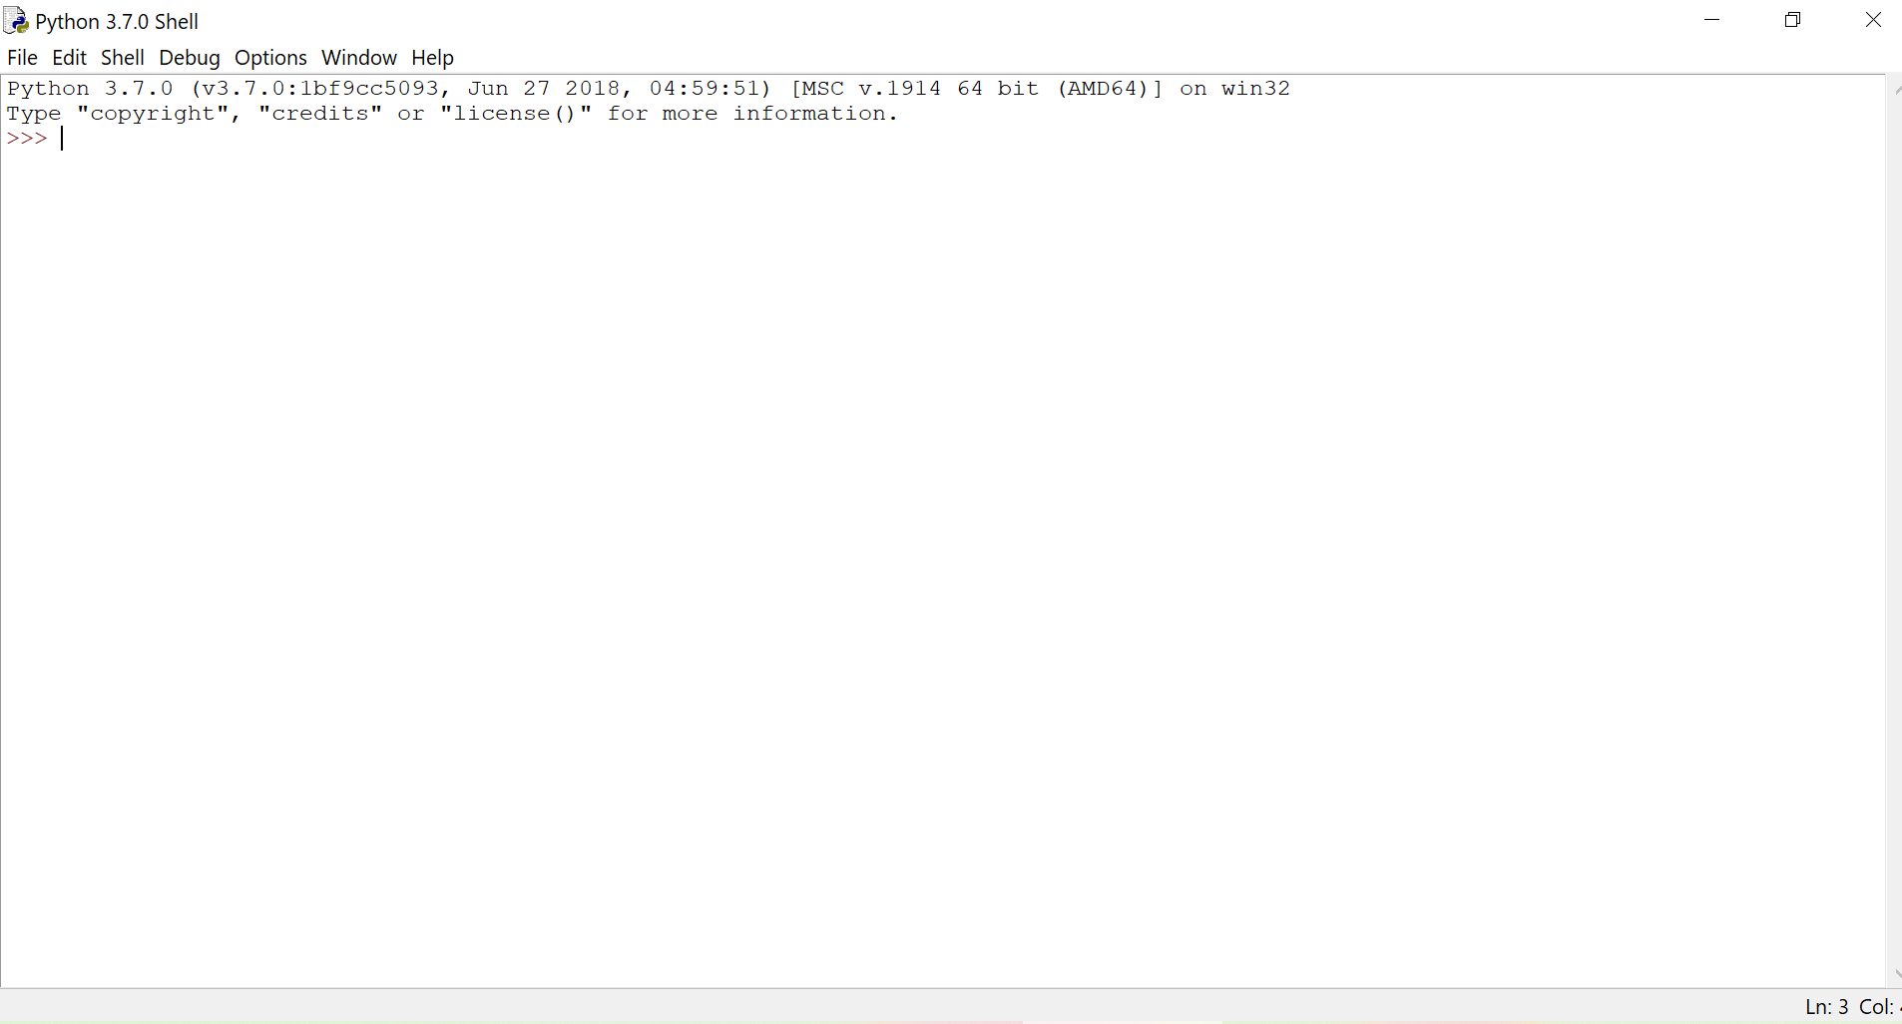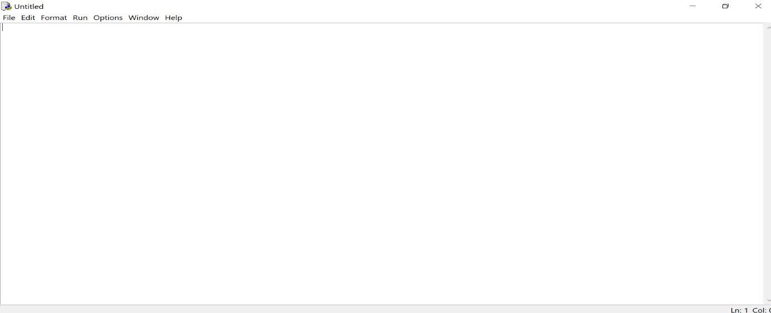

A Python 3.7.0 is installed successfully